class04.R
ricardod.carias
2026-01-16
x <- 1:50
plot(x)
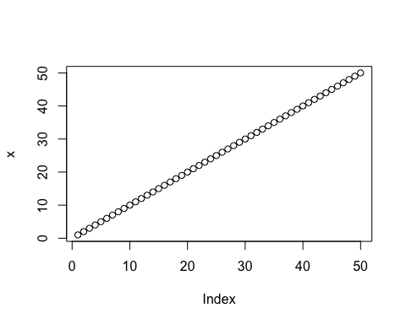
plot(x,sin(x), typ="l", col= "magenta", lwd=5, xlab="Is it lunch time yet?")
